Dopper?
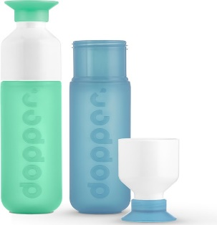
Who is Dopper?
Dopper is a company that makes bottles from recycled plastic. Because Dopper is against pollution, they also recycle things. Dopper works together with other companies that recycle items and that’s how they become bigger. Besides selling bottles, they also sell books to make people aware of how important the environment is.

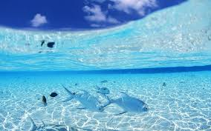
What are the ideas behind Dopper?
A cleaner world
The Dopper was not developed for profit, but as a contribution to a better world. The water bottle is designed to reduce the single use of plastic. Fifty percent of the plastic is discarded immediately after use and ends up in the oceans. One million seabirds and 100,000 marine mammals die as a result. The use of Dopper therefore contributes to a better world.

‘’Dopper bottles are also better for your health‘’
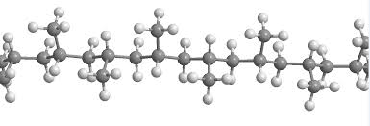
What kind of materials are used for a bottle?
Dopper is free of toxic substances:
Ordinary' plastic water bottles contain the toxic substances, such as BPA Bisphenol A, Phthalates and PVC), which are absorbed by the human body with repeated or even single use of disposable bottles. The
handy cup-shelled Dopper is therefore not only much better for the environment, but also for your health.

**At the back of this leaflet you will find examples of these toxins with the consequences of them**
The normal plastic bottle does contain toxic substances that can affect your health. Here are four examples of these substances with their common consequences:

PVC, polyvinyl chloride, a cheap and easily processed form of plastic. This material is often found in the domestic atmosphere; rainwear, shower curtains and shoe soles. Products made of PVC have the ability to repel certain toxic substances, such as dioxins and mercury. These substances can lead to cancer, hormonal imbalance and disturbance of both the immune and reproductive systems.

PS (polystyrene), is a form of plastic that everyone has come across in the form of disposable cups and cases. This is carcinogenic.

Bisphenol A leads to skin allergens, can be irritating to the eyes, is toxic to the liver after single exposure and is toxic to reproduction. It can cause infertility.

Phthalates in boys can lead to a smaller scrotum and penis and an increased risk of not descended testicles.

