Bello & Eco
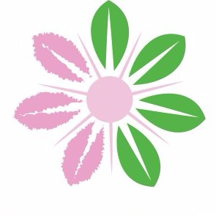
Who is Bello & Eco?
The organization is founded by Mrs. Lav, she started small in 2016, in the Netherlands. The company was founded in Enschede, workplaces can be found in European countries such as the Netherlands, Belgium and Portugal, but you can also find them abroad, in India and Peru.

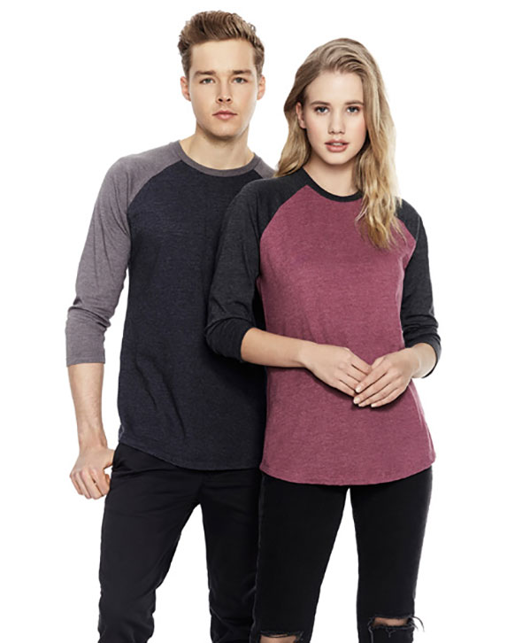
What kinda products do they make?
The company produces sustainable clothing and accessories for women, at first wanted to focus them on women's fashion, but over time they saw in it that also very many men like fashion.

The products are made with organic products, they have better qualities than normal clothing and can last longer. And cleaning the products also uses less energy, because they have to be washed by hand.

The organization uses the money for charity and is also environmentally friendly.
And it gives people who are struggling the opportunity for a job against a well-paid one.

The workplace of the company is spread over European countries, also in Peru and India you will find small studios and factories of the company. In Peru, single mothers work for good wages. In India you will also find a factory where they use green energy (solar panels and wind energy). The working conditions are clean, safe and not too big, which ensures order. How does the company ensure that it gets customers? Well, they do that by sharing their ideas and products on social media, they talk a lot about it and they also organize workshops at schools and universities.

